

ReceiptPro WEB APPLICATION

Prepared by:

**ATHUL DAS**

**Sr. SYSTEM ANALYST**

ReceiptPro is an innovative software that is made to lessen the hassles of receipt data entry. As a better alternative to MS Excel, it is capable of greatly reducing processing times and in executing different functions. Real-time statistics, analytics, and progress of different types of receipts can be viewed and evaluated in ReceiptPro. By assigning project files or receipt files to an individual, they can start the processing and can be done with it in a simplified and quick manner.

To be brief, The ReceiptPro, will reflect multiple benefits for an organization in implementing successful business opertaions.

**USER**

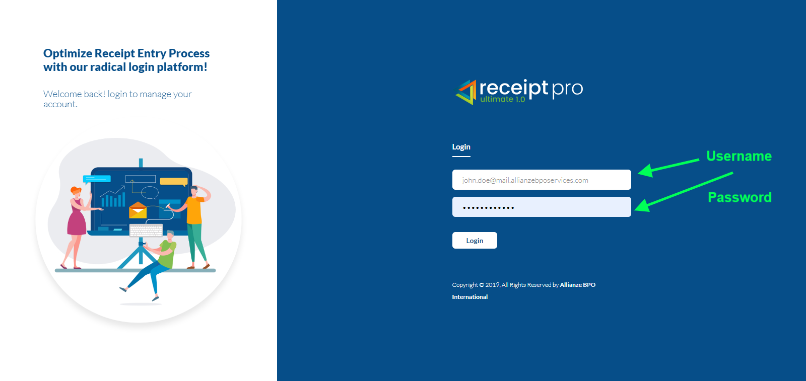

1. Here you can enter your login credentials and click on the ‘Login’ button for access

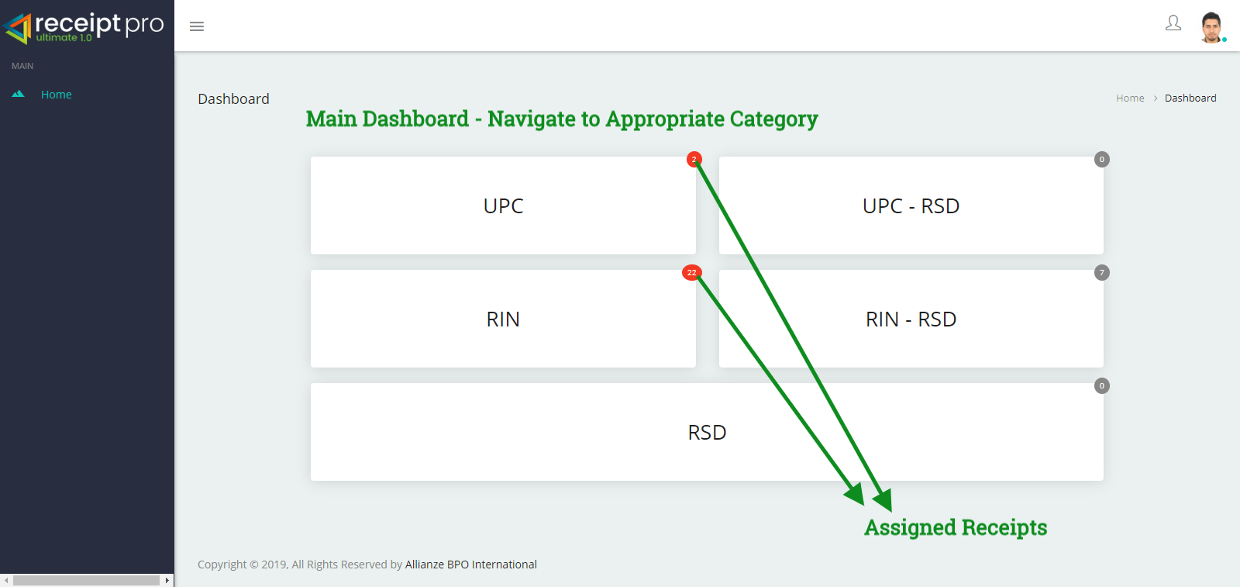

1. The ‘Main Dashboard’ will display the different receipt types with a red circle showing the assigned number of receipts. If no receipts are assigned it will be displayed in a grey circle.

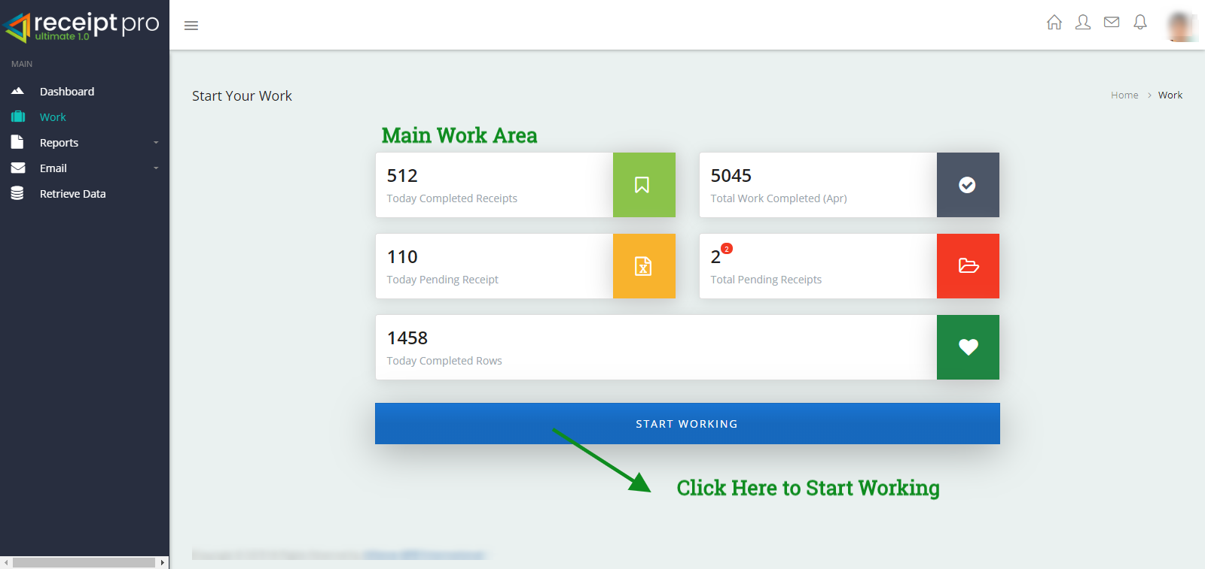

1. The ‘Work’ tab will display today’s current receipt entry status such as: completed, pending, and completed rows. It will also display the total completed receipts in a month as well as the remaining numbers of receipts left incomplete.

By clicking on the ‘Start Working’ button, you can continue the processing from where you have left off or to begin a new one.

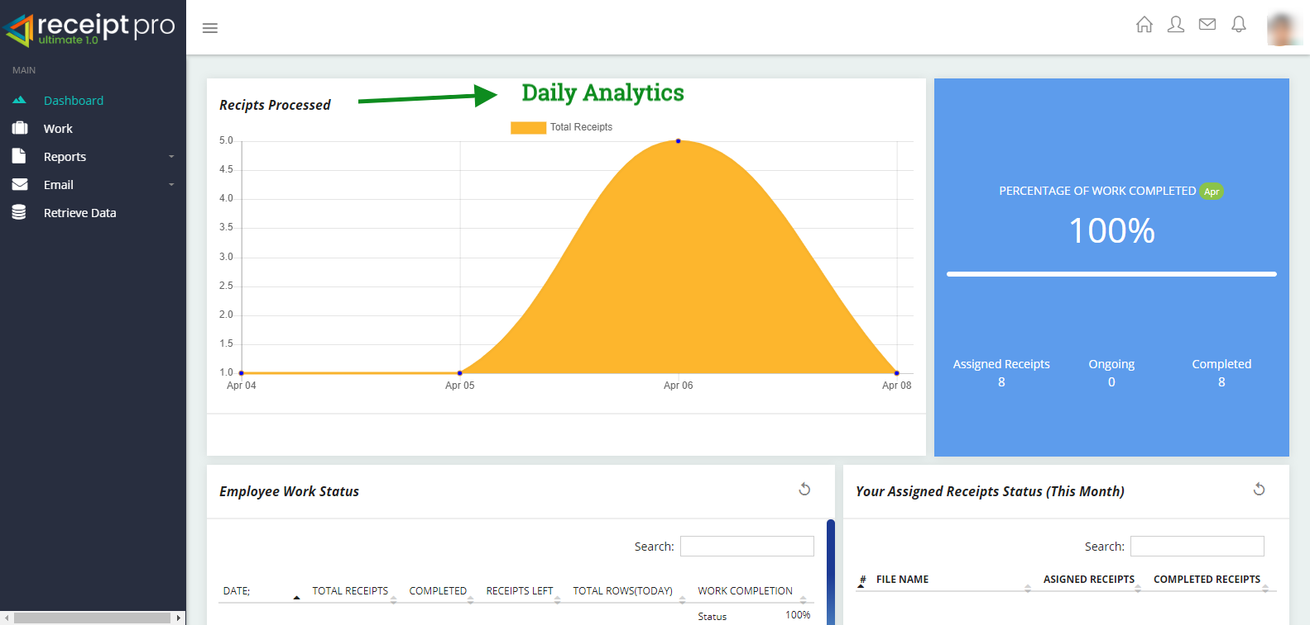

1. ‘User Dashboard’ will display a user’s daily analytics in terms of percentage, assigned, ongoing, or completed receipts.

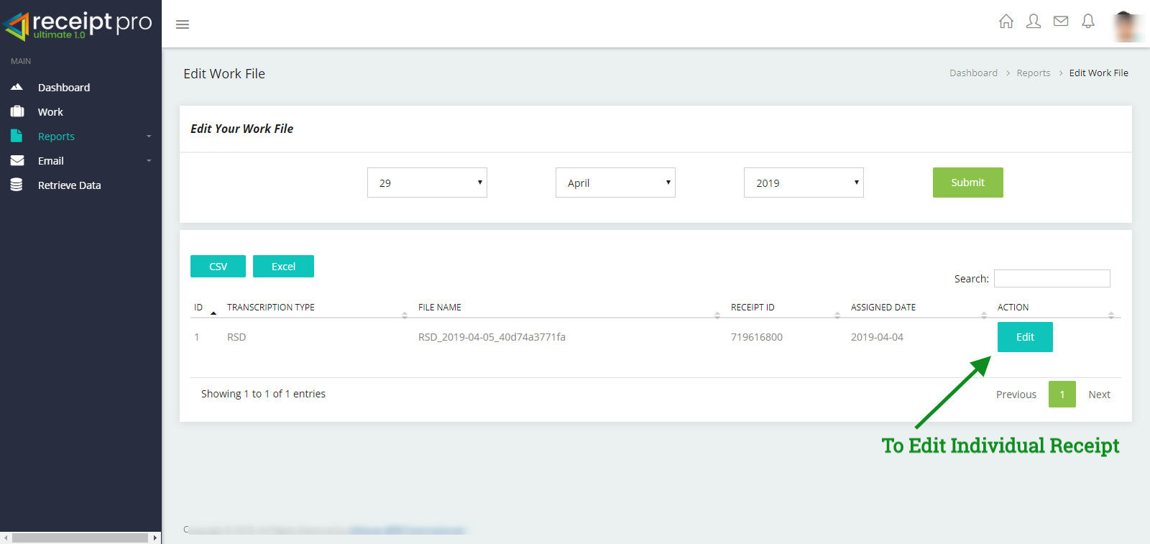

1. You can edit your work file by clicking on the ‘Reports’ tab > Select a specific date and click on the blue ‘Edit’ button that corresponds to the receipt you want to edit. You can identify the receipt you want to edit by looking at the ‘Receipt ID’ given for the displayed receipts.

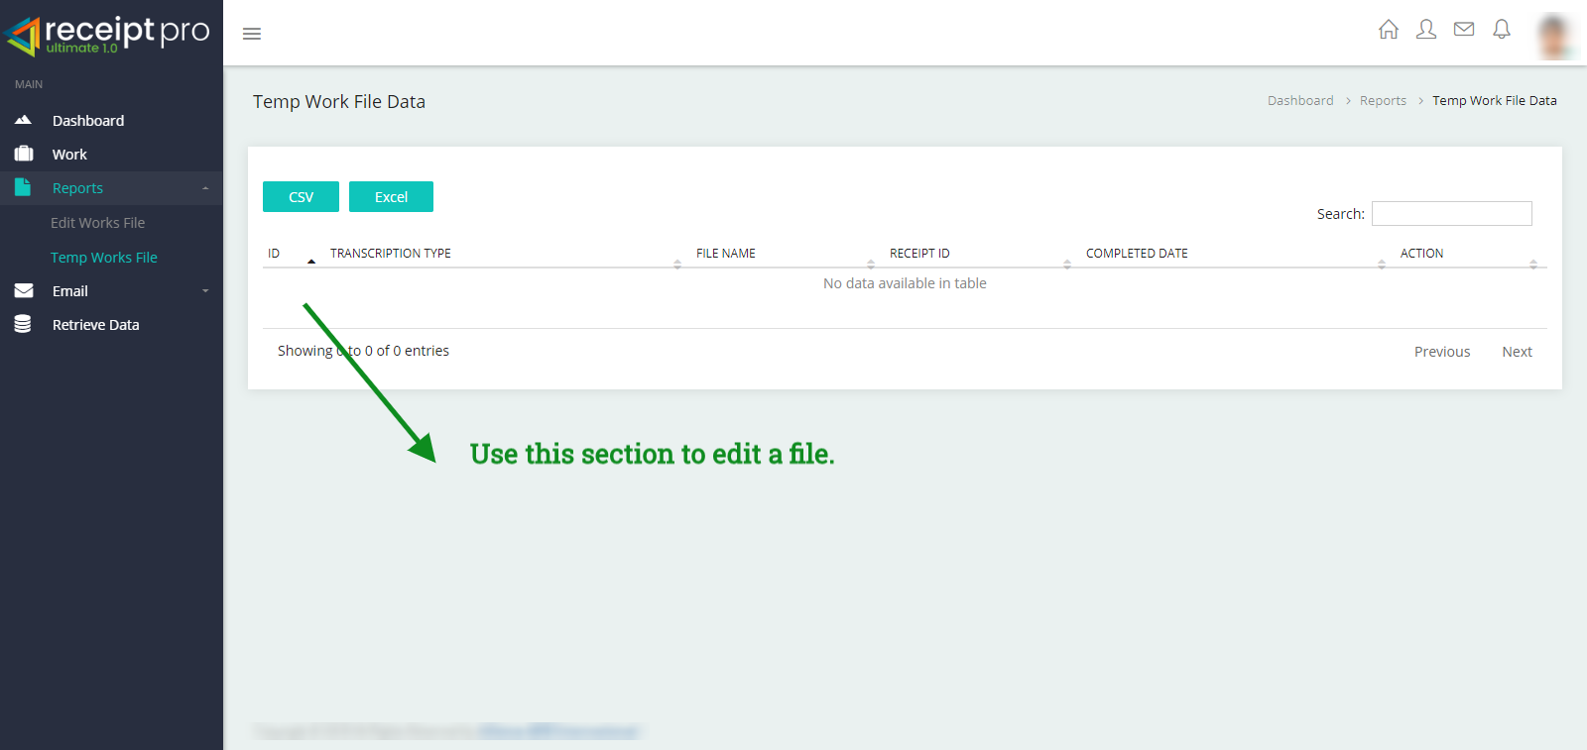

1. The ‘Temp Works File’ will generate a temporary file status for the receipt you are trying to edit.

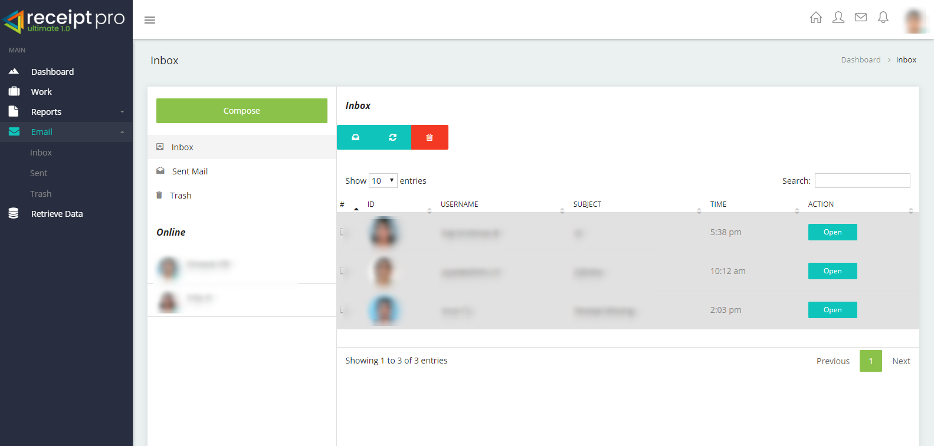

1. The ‘Email’ tab can be used for internal communication of any sort.

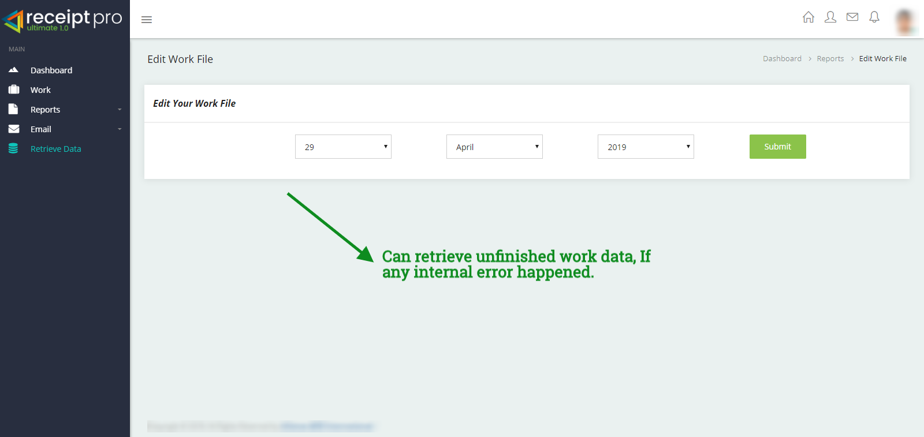

1. You can retrieve any of your unfinished work if any internal error has happened from the ‘Retrieve Data’ tab.

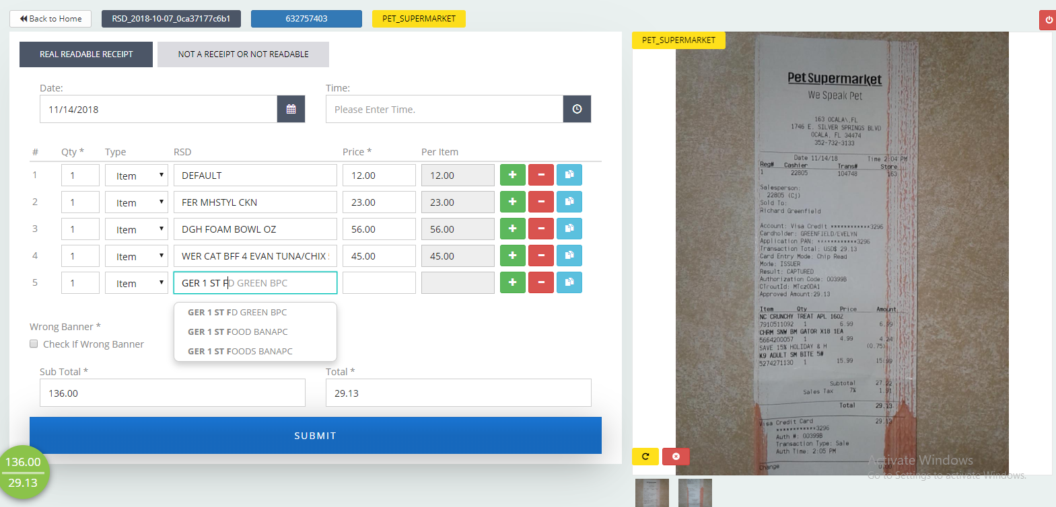

1. On clicking the ‘Start Working’ button, the worksheet page opens up. The top of the worksheet shows the type of receipt, receipt ID and merchant name.

**Conditions**: Always make sure you got the correct merchant name that is displayed in the image and on the worksheet.

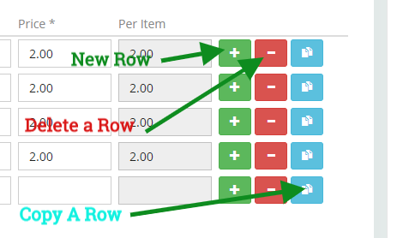

To add a new row, click on the green ‘**+**’ button.

To delete a row, click on the red ‘**-**’ button.

To copy a row, click on the ‘blue’ button.

On typing inside the text field, an autofill option will be available for you to select (based on pre-fetched data in the database) from the available list. If no such autofill list is generated, then please type in the proper name.

On pressing the ‘Enter’ button, a new row will have the focus.

Based on your input value(s), a subtotal of all the values will be displayed on the bottom left of the worksheet.

The image on the right-hand side has options for you to

* Scroll up, down, left and right
* Zooming in and zooming out
* A reset button will restore the image to the default size it was when the worksheet was opened.

**ReceiptPro Shortcuts**

**Row Movements**

* Row Up - **Shift + Up Arrow**
* Row Down - **Shift + Down Arrow**
* Row Left - **Shift + Left Arrow**
* Row Right - **Shift + Right Arrow**
* Create new Row - **Alt + N**
* Delete a row - **Alt + Z**
* Copy a Row - **Ctrl + C**
* Focus on New Line **- Enter** (Also Create a new row.)

**Image Movements**

* Next image - **Ctrl + Right Arrow**
* Previous Image - **Ctrl + Left Arrow**
* Submit a form - - **F9 or Submit Button**

**ADMIN**

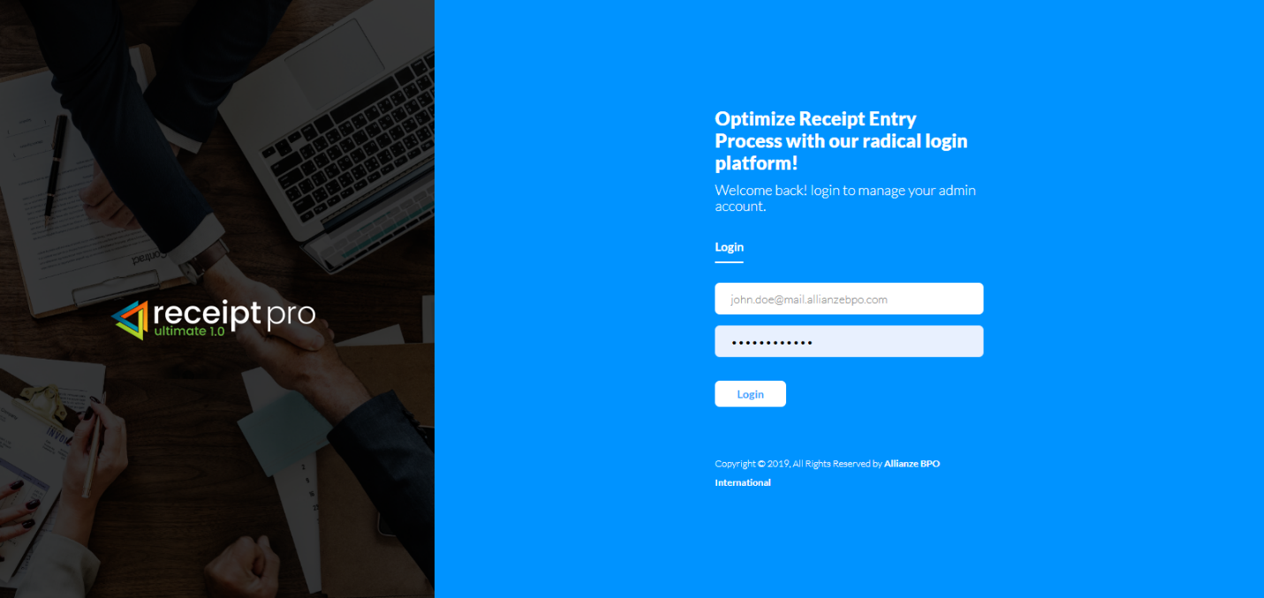

1. Here you can enter your login credentials and click on the ‘Login’ button for access.

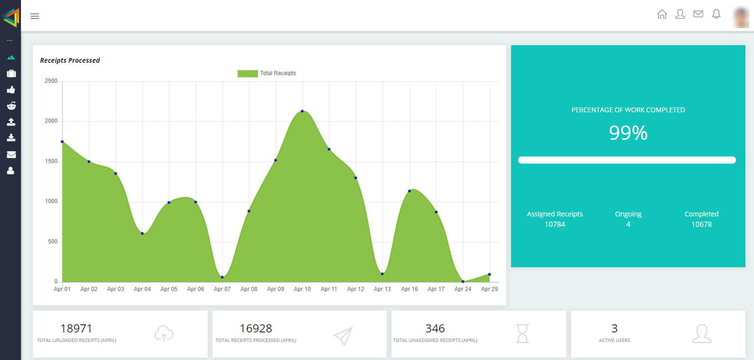

1. Admin Dashboard will give you complete progress of your work in terms of total receipts processed, ongoing and completed and other graphical data.

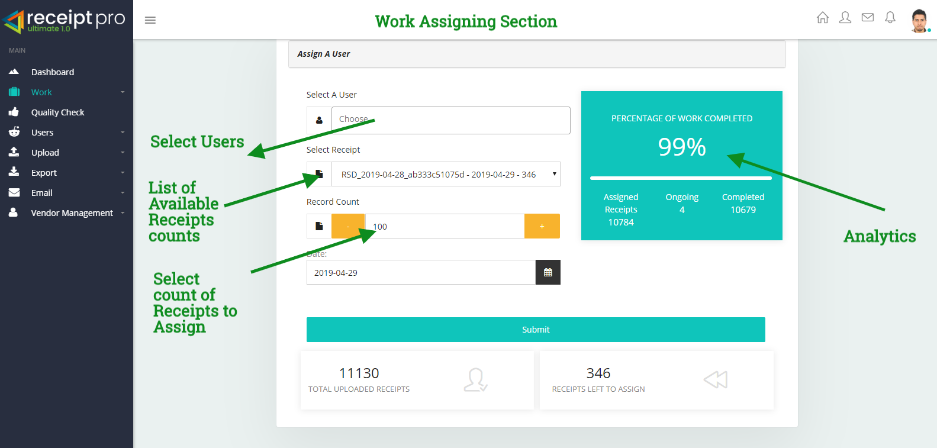

1. The ‘Work’ tab can be used to select users, list of available receipts counts, or to specifically assign certain receipt counts for users. Oh the right-hand side, you can also look at the analytics along with other details.

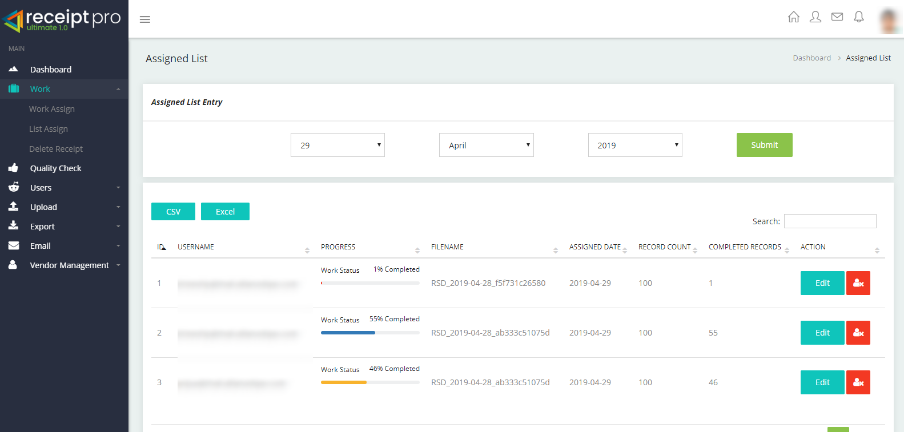

1. When you expand the ‘Work’ tab it will give you a quick view of Assigned List Entry and its history for of all users for a selected date.

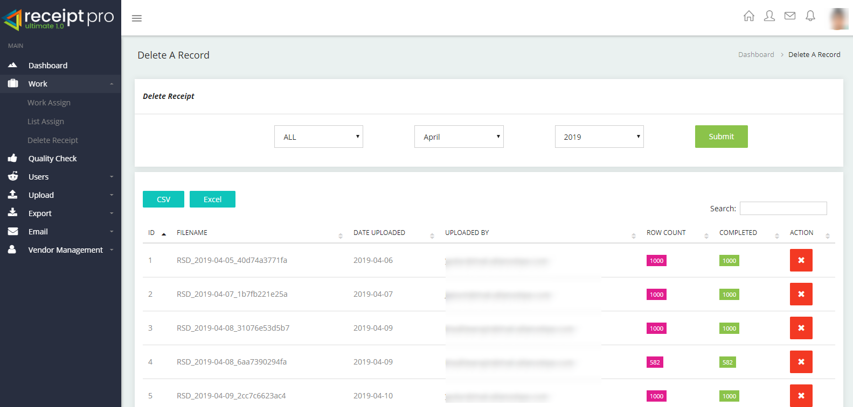

1. There is also an option for deleting uploaded receipts after exporting.

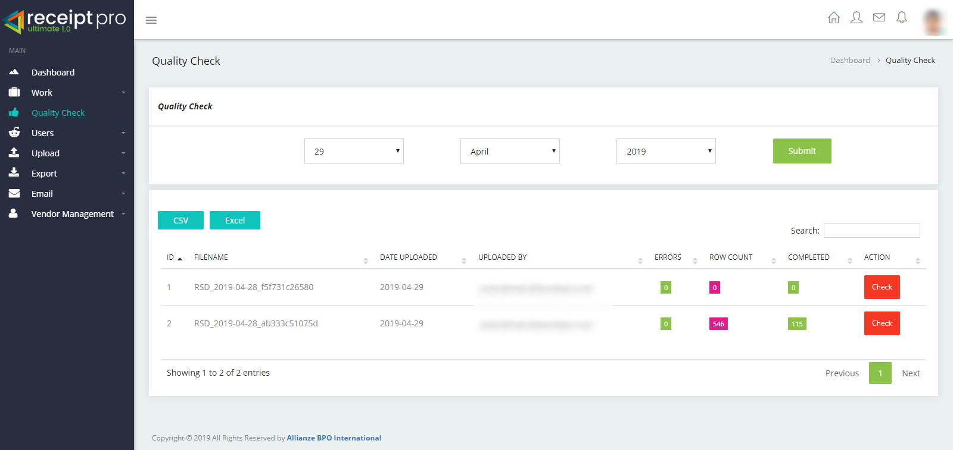

1. The Quality Check tab is used for analyzing the receipt thoroughly for any errors.

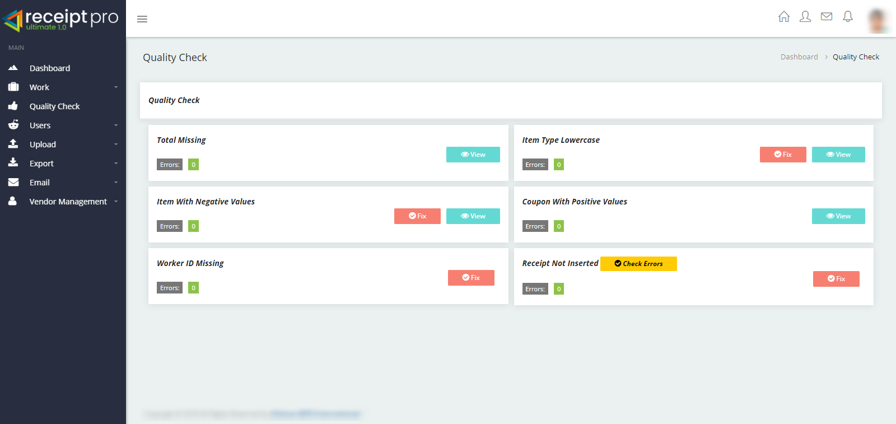

1. The Quality Check tab can also generate QC reports when the ‘Quality’ tab is selected. If a receipt has not uploaded properly or contains errors, you can use or click on the ‘Check Errors’ button manually. If any errors are found in any of the receipts, a red button by the name ‘Fix’ will be enabled automatically. On clicking the button, it will fix all the issues.

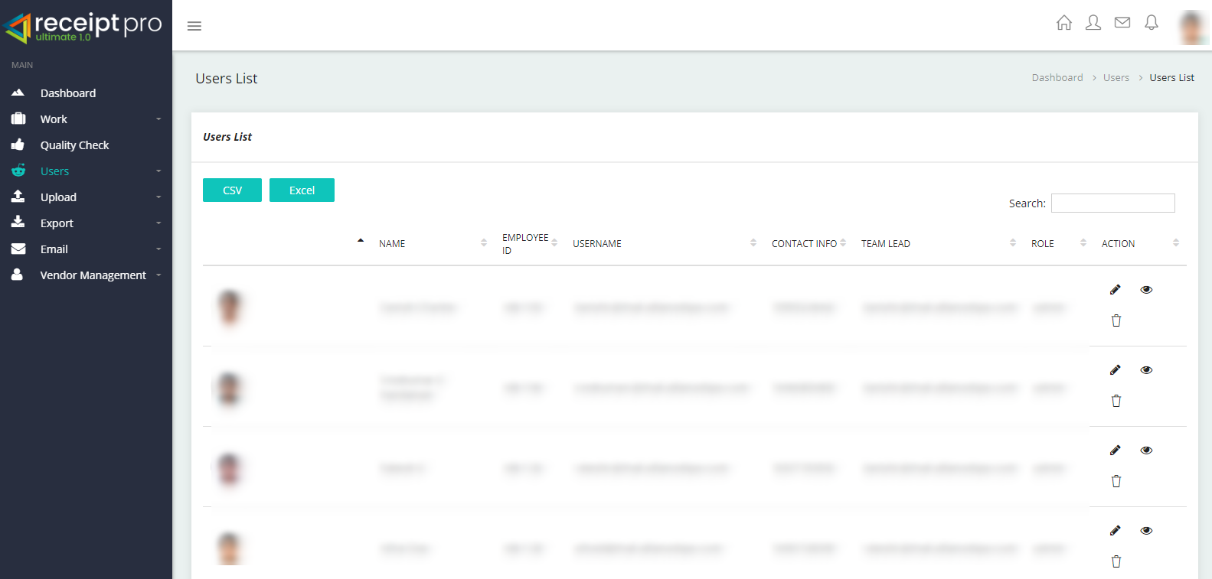

1. The Users List tab will display all the users available. You can also add new users or delete existing ones.

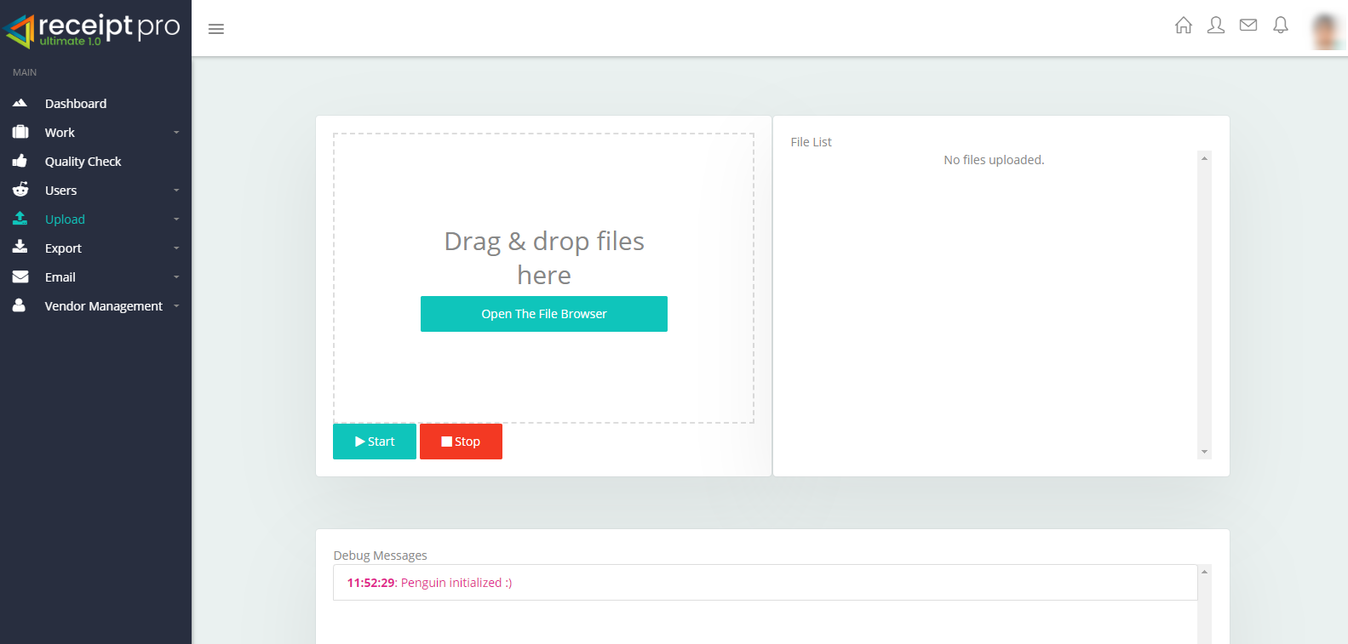

1. The upload tab can be used to upload all types of receipts.

**Conditions**: The file should be of a .zip format.

File size should not exceed 1.2 GB.

The zipped folder must contain an image folder and a .CSV file.

After selecting the zip file click on the start button to begin the receipt upload.

If you experience any issues during the upload, please contact the administrator immediately.

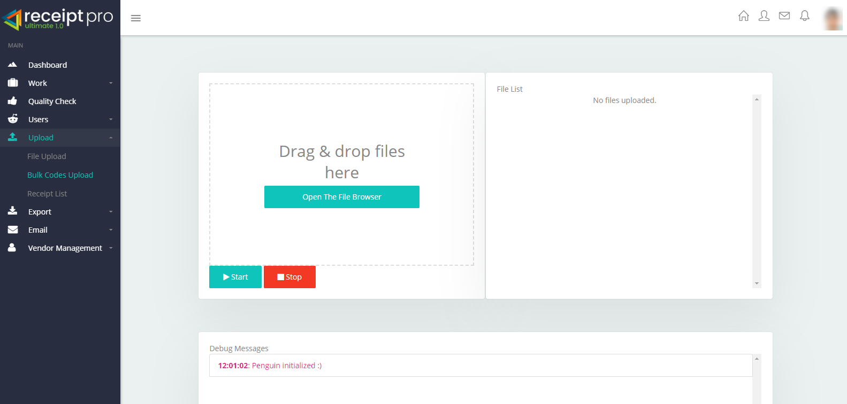

1. The ‘Universal Bulk Codes Upload’ tab can be used to upload bulk product codes. This feature will help you fetch product names from the existing database.

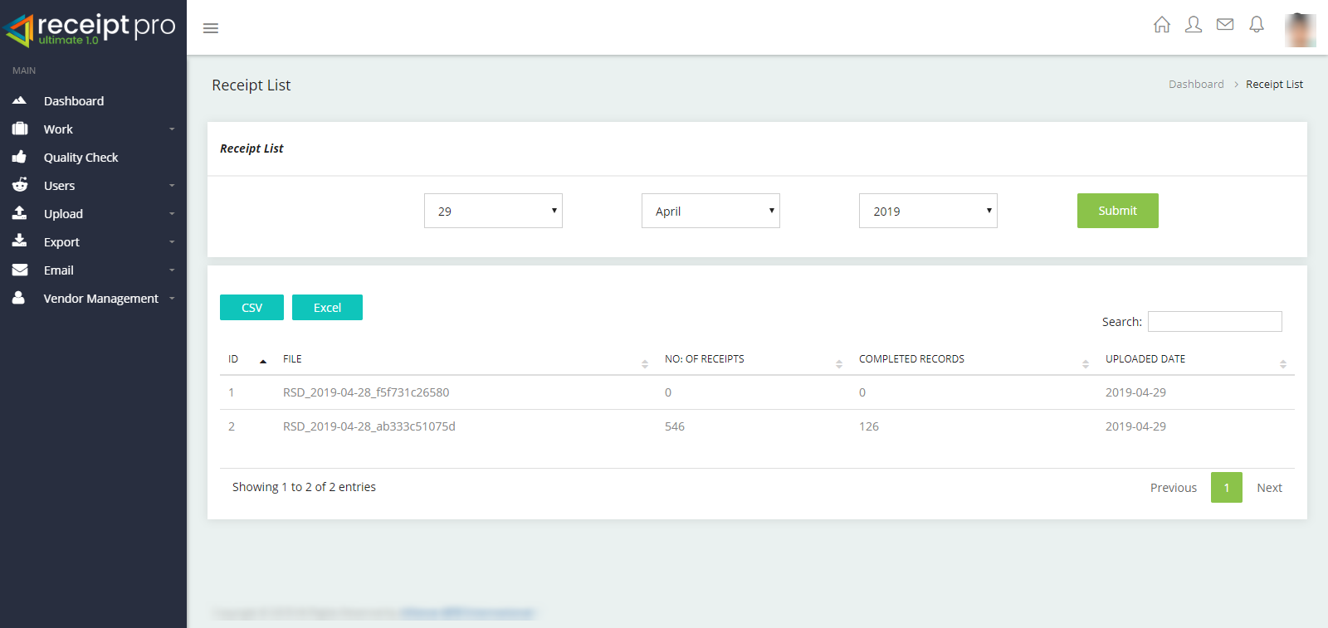

1. The ‘Receipt List’ will display the type of entered receipts on a selected date with its progress.

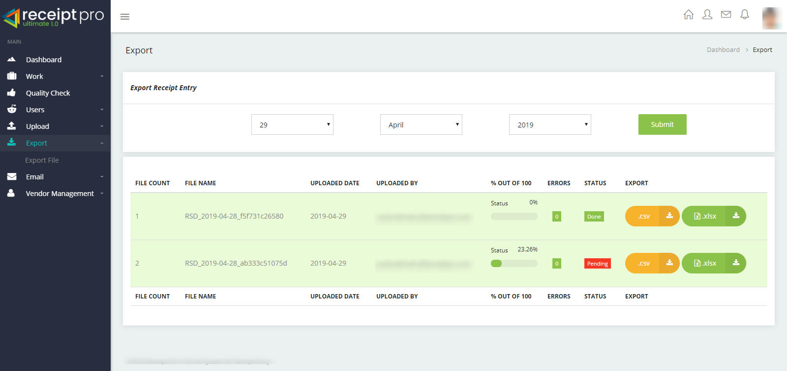

1. The ‘Export Receipt Entry’ tab will provide you to download the final output of the receipt. You can download either. XLSX or .CSV formats. You can also check the progress of the work files of the uploaded receipts.

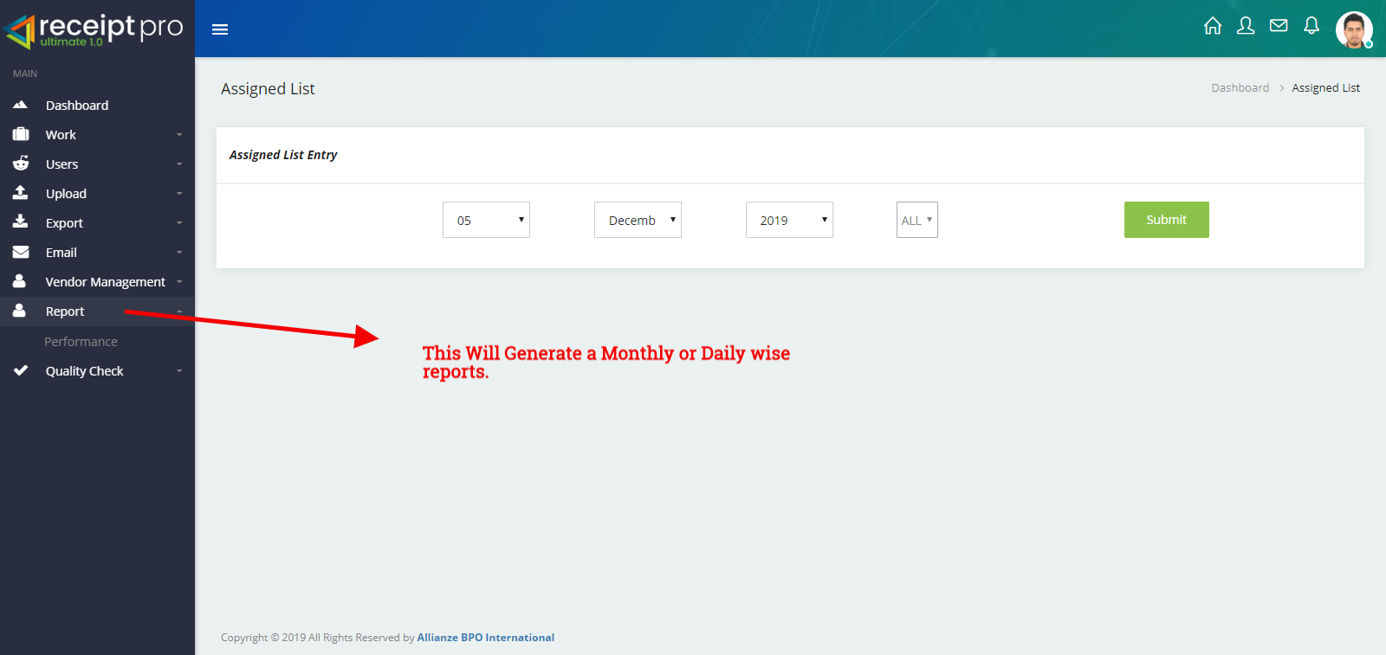

1. Performance Report tab will provide the performance of the each individuals in monthly or daily wise.By choosing the date will list out the name of the receipts that have been processed on the selected date.

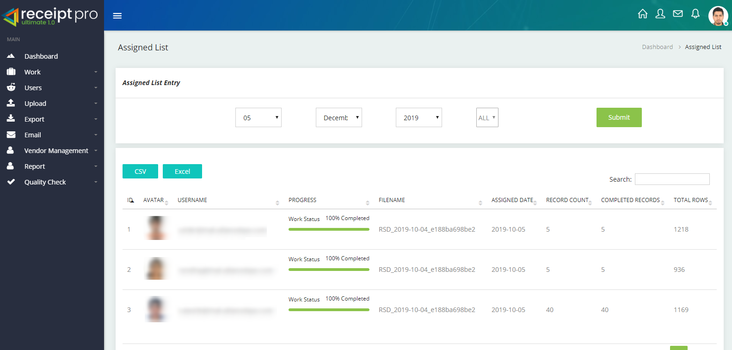

1. QC Section- This portal system will help QC Anlayst to check the quality and errors in the processed receipts. Also this sections can access only by selected users. By selecting a date, the system will list out the receipts that have processed on the selected day.

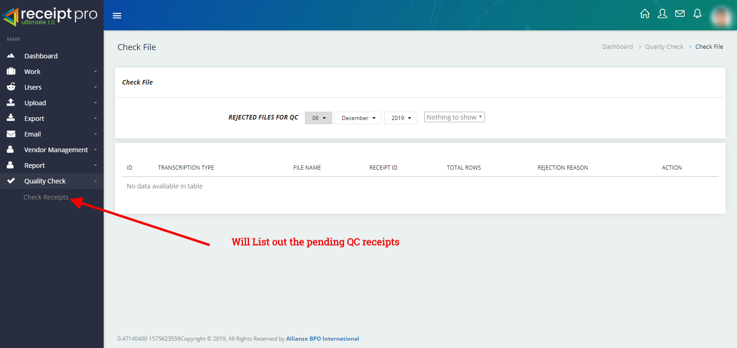

QC analysts can even reject the entry to the corresponding DE person if it is not a valid entry

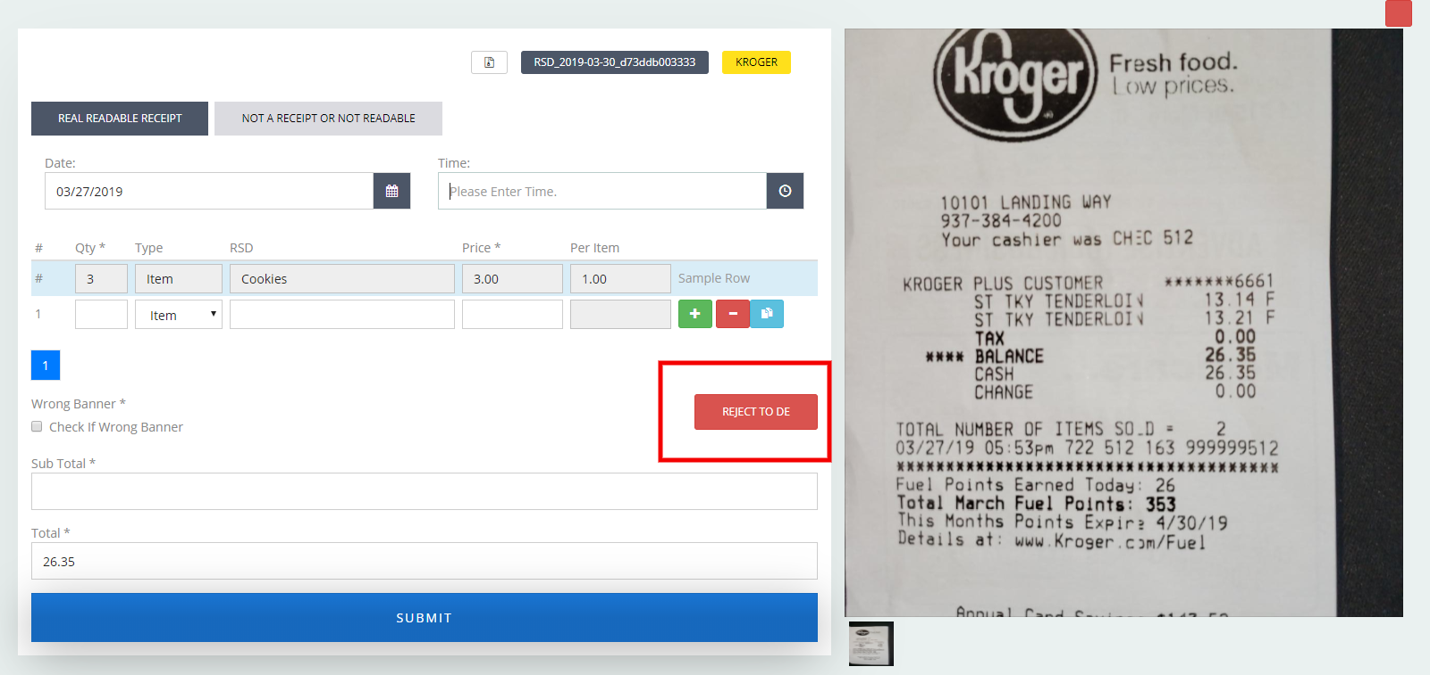

1. The ‘Email’ tab can be used for internal communication of any sort.



**For Any Technical Assistance**

1. **Athul Das**

**Sr. System Analyst**

Email: **athul.das@allianzebpo.com**

Tel: **+91-484-241-30-71** | **+91-484-241-30-81**

Cell: **+91-808-907-0761**

1. **Rakesh C**

**Project Leader**

Email: **rakesh.pillai@allianzebpo.com**

Tel: **+91-484-241-30-71 | +91-484-2413081**

Cell: **+91-903-719-5955**

1. **Sreekumar C Nandanan**

**Project Leader**

Email: **sreekumar.nandanan@allianzebpo.com**

Tel: **+91-484-241-30-71 | +91-484-2413081**

Cell: **+91-944-608-3483**